Country:
Service or Organization:
Surname (Dr/Mr/Ms):
First name:
Address:
Telephone:
Telefax:
E-mail:
Hotel name
Check-in date:
Check-out date:
Type of room: | Non-Smoking/Smoking
Arrival: | Date
Departure: | Date

Date: |  |  | Signature:

Please send this hotel booking form to
Meteorological Satellite Center
E-mail: asuc2-cp@dpc.kishou.go.jp
FAX: +81-42-492-2433
Submission deadline is 28 October 2011

Block bookings can be made for the three hotels listed below, which are around 2 km from the venue. A map is shown on page 3.
- Shiba Park Hotel
Room type: double or twin with breakfast
Room charge: JPY 16,100/night/person for single use
JPY 8,925/night/person for double use
Address: 1-5-10 Shiba Park, Minato-ku, Tokyo 105-0011
Tel.: +81-(0)3-3433-4141
Fax: +81-(0)3-3433-4142
URL: http://www.shibaparkhotel.com/en/
Venue access: Tokyo Metro Toei Oedo Line from Daimon Station (E20) to Azabu-juban Station (E22) (fare: JPY 170). Alternatively, it takes 10 minutes by taxi or 25 minutes on foot.

Direction:

From Narita/Haneda airports to central Tokyo, please see travel information in Page 4.

8-minute walk from Hamamatsucho station on JR / the Tokyo Monorail.

4-minute walk from the metro station E20/A09 (Daimon) on the Toei Oedo/Toei Asakusa line.

2-minute walk from the metro station I06 (Onarimon) on the Toei Mita line.

- Tokyo Prince Hotel
Room type: double with breakfast
Room charge: JPY 18,000/night/person for single use
JPY 10,500/night/person for double use

Address: 3-3-1 Shiba-Koen, Minato-ku, Tokyo 105-8560

Tel.: +81-(0)3-3432-1111

Fax: +81-(0)3-3434-5551

URL: http://www.princehotels.com/en/tokyo/

Venue access: 10 minutes by taxi or 20 minutes on foot

Direction:

From Narita/Haneda airports to central Tokyo, please see travel information in Page 4.

10-minute walk from Hamamatsucho station on JR / the Tokyo Monorail.

7-minute walk from the metro station E20/A09 (Daimon) on the Toei Oedo/Toei Asakusa line.

7-minute walk from the metro station E21 (Akabanebashi) on the Toei Oedo line.

1-minute walk from the metro station I06 (Onarimon) on the Toei Mita line.

- Chisun Hotel Hamamatsucho
Room type: single with breakfast
Room charge: JPY 11,000/night/person for single use
Address: 1-3-10, Shibaura, Minato-ku, Tokyo 105-0023
Tel.: +81-(0)3-3452-6511
Fax: +81-(0)3-3452-9241
URL: http://www.solarehotels.com/english/chisun/hotel-hamamatsucho/guestroom/detail.html
Venue access: 10 minutes by taxi or 25 minutes on foot

Direction:

From Narita/Haneda airports to central Tokyo, please see travel information in Page 4.

8-minute walk from Hamamatsucho station on JR / the Tokyo Monorail.

7-minute walk from Hinode station on Tokyo Waterfront New Transit ‘Yurikamome’.

11-minute walk from the metro station E20/A09 (Daimon) on the Toei Oedo/Toei Asakusa line.

9-minute walk from the metro station I04/A08 (Mita) on the Toei Mita/Toei Asakusa line.
Hotel & Conference Venue Map
Travel to Tokyo
Narita Airport and Haneda Airport are the major international air hubs serving Tokyo.

From Narita Airport
Most international flights arrive at Narita International Airport, located about 60 km east of central Tokyo. There are many ways to get to central Tokyo. Please refer to the airport access information at http://www.narita-airport.jp/en/access/index.html.
- Airport Limousine Bus
Departures are approximately once every 15 minutes, and the trip to the Shiba Park Hotel/Tokyo Prince Hotel takes about two hours. The fare is JPY 3,000. More information is available at http://www.limousinebus.co.jp/en/.
- Train
The two train services outlined below run from Narita Airport to central Tokyo. For directions from central Tokyo stations to your hotel, please see the hotel’s website.
- Narita Express
Departures are once every 30 – 60 minutes, and the trip to Tokyo Station takes about an hour. The fare is JPY 3,140. Although there are various destinations, all trains stop at Tokyo Station. More information is available at http://www.jreast.co.jp/e/nex/index.html.
- Skyliner
Departures are approximately once every 30 minutes, and the trip to Ueno Station takes 40 to 50 minutes. The fare is JPY 2,400. More information is available at http://www.keisei.co.jp/keisei/tetudou/skyliner/us/.
- Taxi (not recommended)
Taxis are also available, but the trip to central Tokyo would be very expensive (JPY 15,000 – 25,000).
From Haneda Airport
Haneda International Airport is located about 20 km south of central Tokyo. There are a number of ways to get to central Tokyo. Please refer to the airport access information at http://www.haneda-airport.jp/inter/en/.
- Airport Limousine Bus
Departures are approximately once every 60 minutes, and the trip to the Shiba Park Hotel/Tokyo Prince Hotel takes about 60 minutes. The fare is JPY 900. More information is available at http://www.limousinebus.co.jp/en/.
- Train
The two train services outlined below run from Haneda Airport to central Tokyo. For directions from central Tokyo stations to your hotel, please see the hotel’s website.
- Tokyo Monorail
Departures are once every 5 – 10 minutes, and the trip to Hamamatsucho Station takes about 30 minutes. The fare is JPY 470. More information is available at http://www.tokyo-monorail.co.jp/english/.
- Keikyu Line
Departures are once every 5 – 10 minutes, and the trip to Shinagawa Station takes about 30 minutes. The fare is JPY 400. More information is available at http://www.haneda-tokyo-access.com/en/.
- Taxi (not recommended)
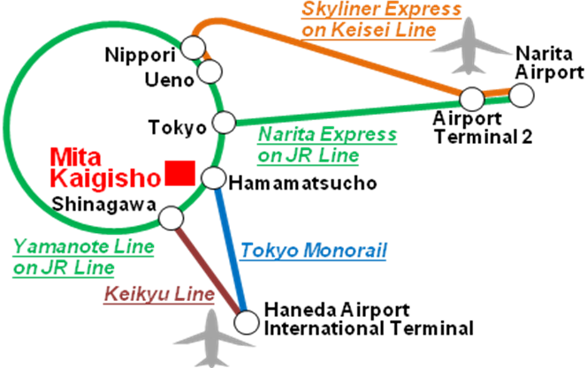
Taxis are also available, but the trip to central Tokyo would be very expensive (approx. JPY 6,000).

